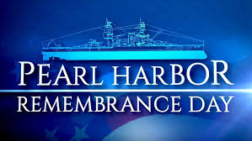

Newport’s own VFW Post 406 will commemorate
The
78^{th.} Anniversary of the Attack on Pearl Harbor
By
Laying a Wreath
In
Honor of those who lost their lives
In
Service to Our Great Nation

Saturday 07 DEC 2019, 0830
Newport WWII Memorial, 43 Broadway, Newport

